Clock code
module clk(Clk,data_out);
//declare input and output
input Clk;
output [7:0] data_out;
//declare the sine ROM - 30 registers each 8 bit wide.
reg [7:0] sine [0:29];
//Internal signals
integer i;
reg [7:0] data_out;
//Initialize the sine rom with samples.
initial begin
i = 0;
sine[0] = 0;
sine[1] = 16;
sine[2] = 31;
sine[3] = 45;
sine[4] = 58;
sine[5] = 67;
sine[6] = 74;
sine[7] = 77;
sine[8] = 77;
sine[9] = 74;
sine[10] = 67;
sine[11] = 58;
sine[12] = 45;
sine[13] = 31;
sine[14] = 16;
sine[15] = 0;
sine[16] = -16;
sine[17] = -31;
sine[18] = -45;
sine[19] = -58;
sine[20] = -67;
sine[21] = -74;
sine[22] = -77;
sine[23] = -77;
sine[24] = -74;
sine[25] = -67;
sine[26] = -58;
sine[27] = -45;
sine[28] = -31;
sine[29] = -16;
end
//At every positive edge of the clock, output a sine wave sample.
always@ (posedge(Clk))
begin
data_out = sine[i];
i = i+ 1;
if(i == 29)
i = 0;
end
endmodule

TEST BENCH for(1.023Mhz)
module tb();
// Inputs
reg Clk;
// Outputs
wire [7:0] data_out;
// Instantiate the Unit Under Test (UUT)
clk c1 (
.Clk(Clk),
.data_out(data_out)
);
//Generate a clock with 10 ns clock period.
initial Clk = 0;
always #488.7585 Clk = ~Clk;
endmodule

SIMULATION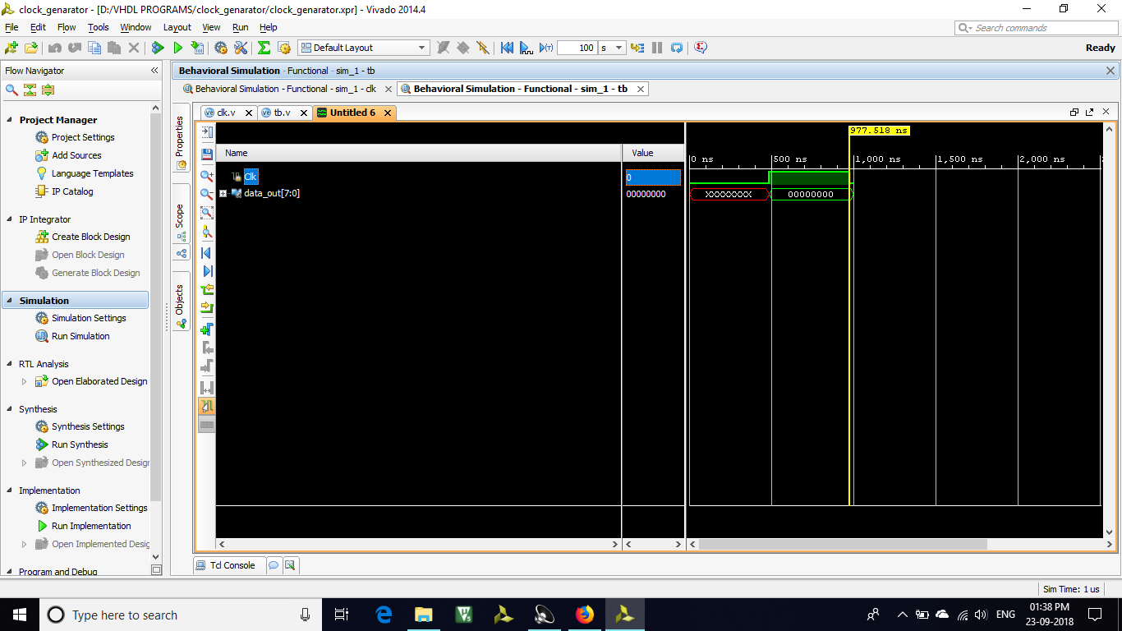
T_{p} = 977.518 ms
f=1/T_{p} = 1/977.518 = 1.023MHz

TESTBENCH (600Hz)
module tb();
// Inputs
reg Clk;
// Outputs
wire [7:0] data_out;
// Instantiate the Unit Under Test (UUT)
clk c1 (
.Clk(Clk),
.data_out(data_out)
);
//Generate a clock with 10 ns clock period.
initial Clk = 0;
always #833000 Clk = ~Clk;
endmodule

SIMULATION
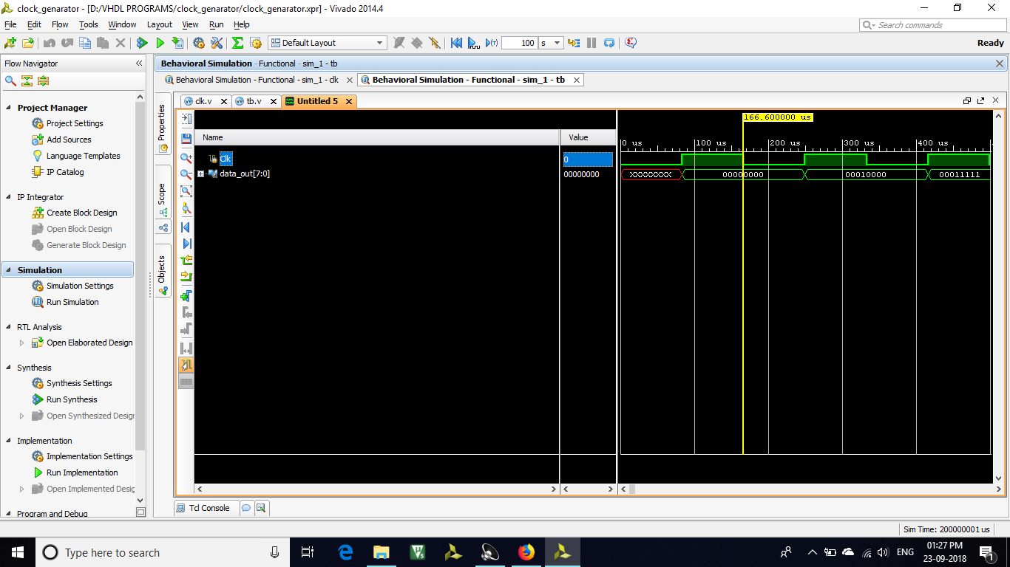
T_{p} = 166.6us
f=1/T_{p} = 1/166.6= 600Hz

